Assignment-4
1-Check Even/Odd and Positive/Negative Take a number and determine whether it is positive/negative/zero and, if applicable, whether it is even or odd.
import java.util.Scanner;
public class Q1 {
public static void main(String[] args) {
Scanner sc = new Scanner(System.in);
System.out.print("Enter a number: ");
int num = sc.nextInt();
if (num > 0) {
System.out.println("Positive");
if (num % 2 == 0)
System.out.println("Even");
else
System.out.println("Odd");
} else if (num < 0) {
System.out.println("Negative");
if (num % 2 == 0)
System.out.println("Even");
else
System.out.println("Odd");
} else {
System.out.println("Zero");
}
sc.close();
}
}
OUTPUT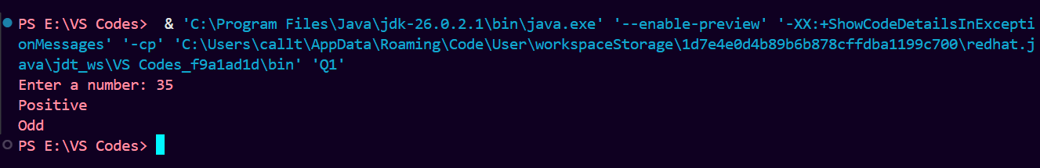

2-Largest of Three Numbers Take three numbers and find the largest using if-else
import java.util.Scanner;
public class Q2 {
public static void main(String[] args) {
Scanner sc = new Scanner(System.in);
System.out.print("Enter first number: ");
int a = sc.nextInt();
System.out.print("Enter second number: ");
int b = sc.nextInt();
System.out.print("Enter third number: ");
int c = sc.nextInt();
if (a >= b && a >= c)
System.out.println("Largest: " + a);
else if (b >= a && b >= c)
System.out.println("Largest: " + b);
else
System.out.println("Largest: " + c);
sc.close();
}
}
OUTPUT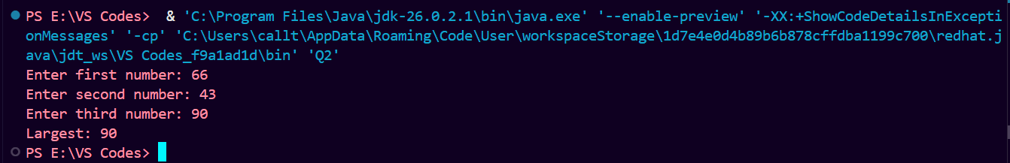

3-Number Divisibility Checker Take a number and check whether it is divisible by 5. If yes, further check whether it is also divisible by 10.
import java.util.Scanner;
public class Q3 {
public static void main(String[] args) {
Scanner sc = new Scanner(System.in);
System.out.print("Enter a number: ");
int num = sc.nextInt();
if (num % 5 == 0) {
System.out.println("Divisible by 5");
if (num % 10 == 0)
System.out.println("Also divisible by 10");
else
System.out.println("Not divisible by 10");
} else {
System.out.println("Not divisible by 5");
}
sc.close();
}
}
OUTPUT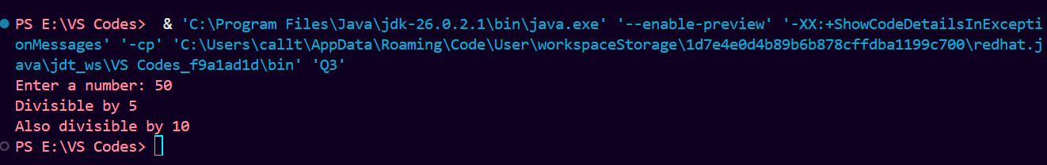
4-Check Working Day Take a day number (1–7) and determine whether it is a working day or weekend.
import java.util.Scanner;
public class Q4 {
public static void main(String[] args) {
Scanner sc = new Scanner(System.in);
System.out.print("Enter day number (1-7): ");
int day = sc.nextInt();
if (day >= 1 && day <= 5)
System.out.println("Working Day");
else if (day == 6 || day == 7)
System.out.println("Weekend");
else
System.out.println("Invalid Day");
sc.close();
}
}
OUTPUT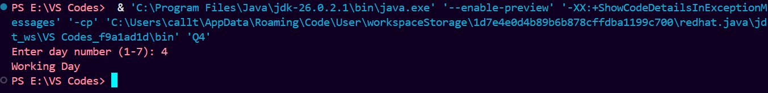

5-Password Length Checker Check whether a password is less than 8 characters, acceptable, or strong based on its length.
import java.util.Scanner;
public class Q5 {
public static void main(String[] args) {
Scanner sc = new Scanner(System.in);
System.out.print("Enter password: ");
String password = sc.nextLine();
int length = password.length();
if (length < 8)
System.out.println("Password is too short");
else if (length <= 11)
System.out.println("Password is acceptable");
else
System.out.println("Password is strong");
sc.close();
}
}
OUTPUT